Overwrite Bootstrap Styles
There are three ways you can overwrite Bootstrap styles:
- Inline style
- Style definition on the page
- Style definition in custom stylesheet
There are different scenarios that best suit each way:
- If the style is shared across the whole project, define it in the custom stylesheet to maintain consistency and avoid duplication. For example, if I’d like to add in a definition for a button that has our CQUni green colour, it is ideal to add this in our custom stylesheet so that this definition is accessible across the whole project.
- If the style is only specific to a certain page, define it on that page by targeting the element and using style tag at page top or bottom.
- Be careful when you use inline styling. It is not good programming practice to use many inline stylings. It is hard to track and maintain. Only use inline styling when that style is unique to an element and won’t be reused elsewhere in the project. Inline styling is achieved by specifying style attribute in the specific element you want to style.
You will learn to do these customisations in this Hands-on Project.
- Open the index.html file you just created in Sublime, or keep it open if you are continuing on from Hands-on Project 2.

- The first change we want to make is to overwrite the text in the alert to be bold.

- First, let’s do it through inline style definition.

- Find the line where you define the ‘div’ element.

- Add the style attribute as shown below:
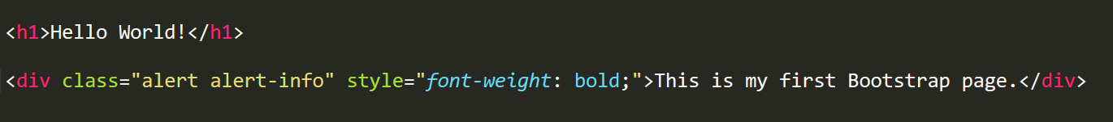
In a style element, you are able to add any valid CSS code.
- Refresh or open the page in your browser and you’ll find that text has been bolded.
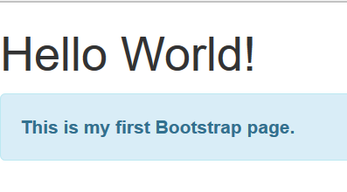
- Now let’s target the element and overwrite it using style tag.

- Remove the inline style you just put in and add the style tag as shown below:
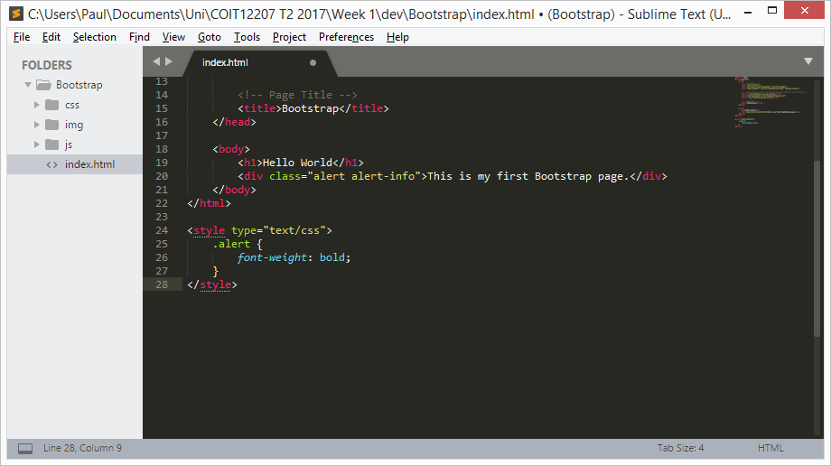
- Refresh the page and you shouldn’t notice any difference (the same effects are achieved).

- Now let’s create a custom stylesheet and overwrite it there.

- Remove the style tag you just put in. Expand ‘css’ folder and right click to create a new file.
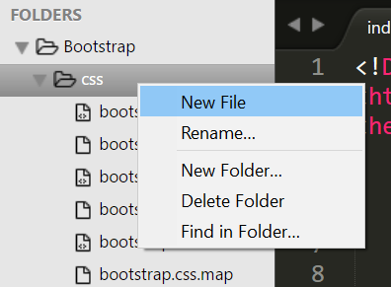

- Save it as custom.css
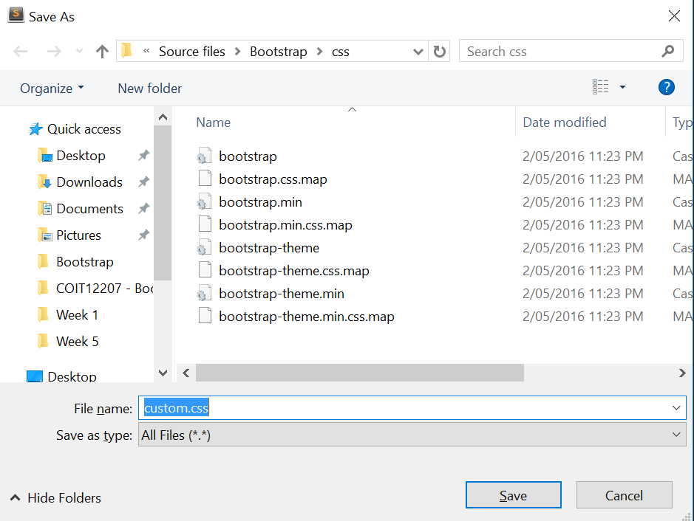
- Reference it in the html head of your index.html file. If you don’t load your custom stylesheet, it won’t have any effect on your page.
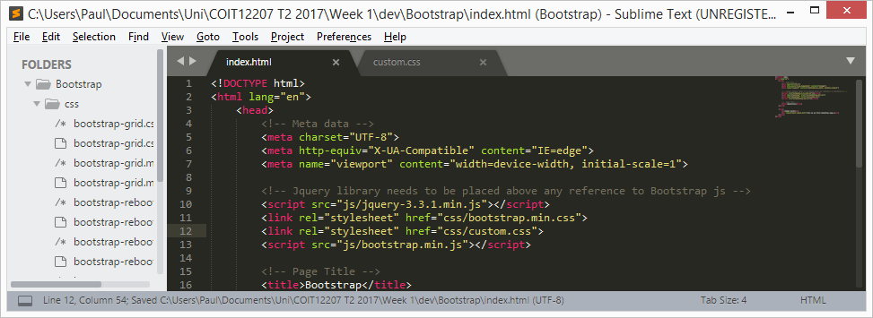
- In your custom.css file, add the following code to overwrite the style:
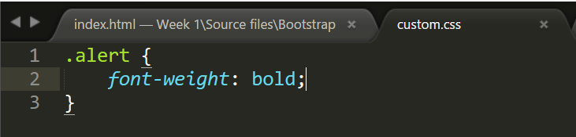
- Refresh the page in your browser and you should observe the text is still bolded.
Conclusion:
We have seen that there are different ways to overwrite a style. However, by using inline styling, the overridden style will only apply to that particular alert. If we overwrite it using style tag, it will impact all the alerts on that page. If we overwrite it in our custom stylesheet, all the alerts in the project will be impacted.

(Reviewed and updated on 23 July. 2023)

